1. [SELECT](http://localhost/phpmyadmin/url.php?url=https://dev.mysql.com/doc/refman/8.0/en/select.html" \t "mysql_doc) Nama\_Barang, Tanggal\_Expired, Harga\_User, Stok\_Barang FROM `obat` ORDER BY Stok\_Barang ASC;

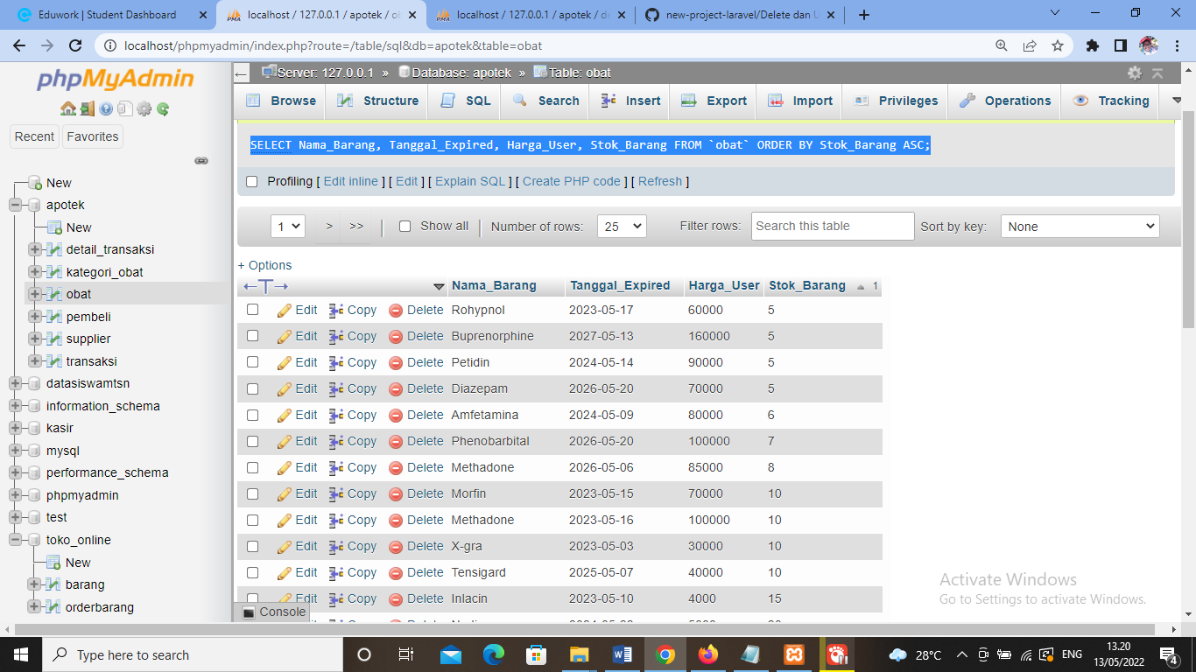

1. [SELECT](http://localhost/phpmyadmin/url.php?url=https://dev.mysql.com/doc/refman/8.0/en/select.html) obat.Kode\_Kategori, Nama\_Barang, Nama\_kategori FROM `obat` JOIN kategori\_obat ON obat.Kode\_Kategori = kategori\_obat.kode\_Kategori ORDER BY kategori\_obat.kode\_Kategori ASC;

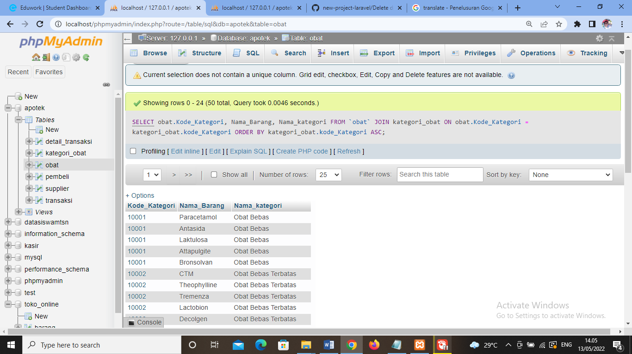

1. [SELECT](http://localhost/phpmyadmin/url.php?url=https://dev.mysql.com/doc/refman/8.0/en/select.html) obat.Kode\_Kategori, Nama\_Barang, Nama\_Kategori, Stok\_Barang, Tanggal\_Expired FROM `obat` [RIGHT](http://localhost/phpmyadmin/url.php?url=https://dev.mysql.com/doc/refman/8.0/en/string-functions.html#function_right) JOIN kategori\_obat ON obat.Kode\_Kategori = kategori\_obat.kode\_Kategori ORDER BY kategori\_obat.kode\_Kategori ASC;

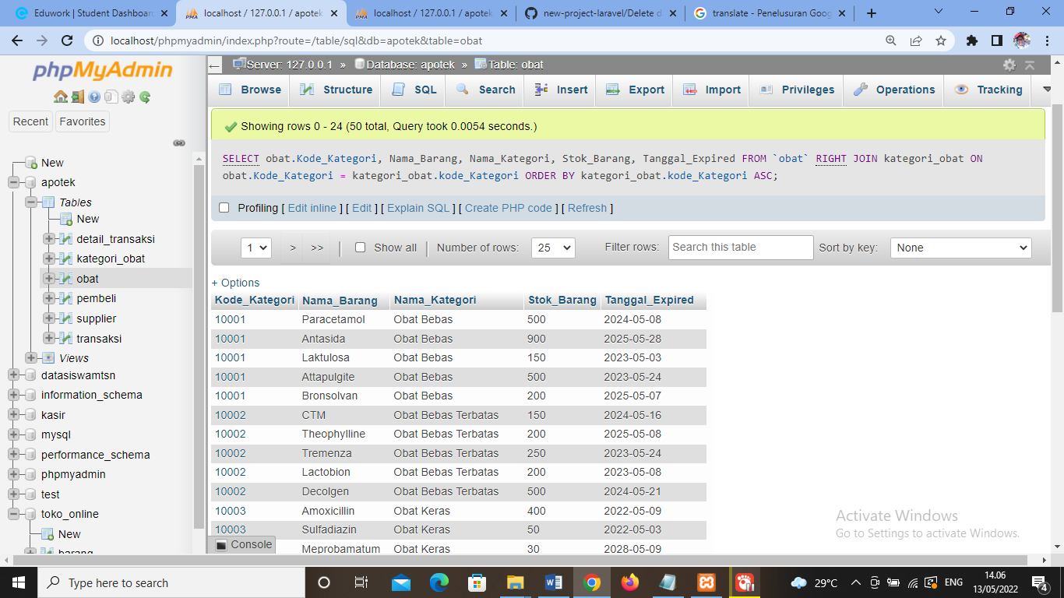

1. [SELECT](http://localhost/phpmyadmin/url.php?url=https://dev.mysql.com/doc/refman/8.0/en/select.html) obat.Kode\_Kategori, Nama\_Barang, Nama\_Kategori, Stok\_Barang, Tanggal\_Expired FROM `obat` [LEFT](http://localhost/phpmyadmin/url.php?url=https://dev.mysql.com/doc/refman/8.0/en/string-functions.html#function_left) JOIN kategori\_obat ON obat.Kode\_Kategori = kategori\_obat.kode\_Kategori ORDER BY kategori\_obat.kode\_Kategori ASC;

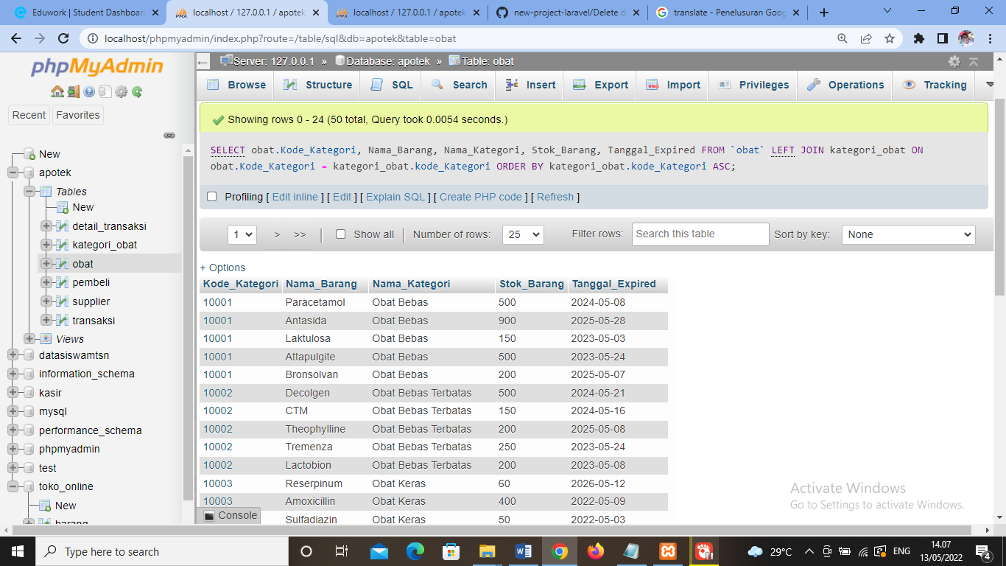

1. [SELECT](http://localhost/phpmyadmin/url.php?url=https://dev.mysql.com/doc/refman/8.0/en/select.html) Nama\_Supplier FROM `supplier` WHERE Alamat [LIKE](http://localhost/phpmyadmin/url.php?url=https://dev.mysql.com/doc/refman/8.0/en/string-comparison-functions.html#operator_like) '%JAKARTA%' ORDER BY Nama\_Supplier ASC;

